##### Using Camera485 with the XLink-500

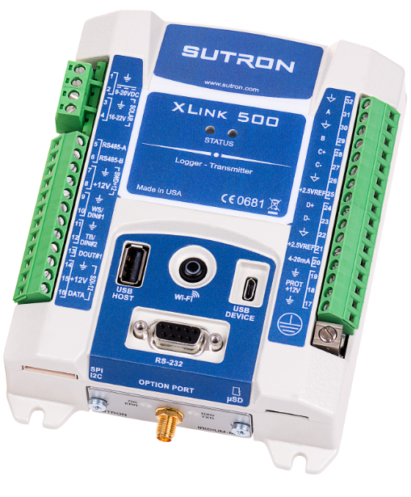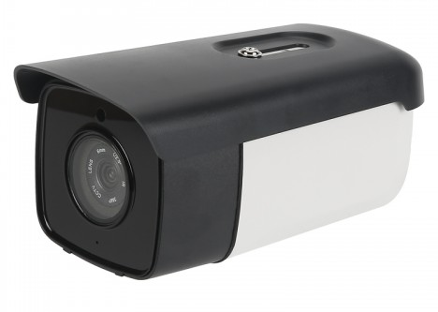

**May 2021**

**Version 2.1**

### **Introduction**

Here are some of the features of the camera (*):

* Weatherproof enclosure (IP67)
* 2 mega pixels CMOS color sensor
* Various 4:3 and 16:9 resolutions from as small as 480x270 up to 1920x1080
* Selectable JPEG compression level
* Low light operation (0.0005 lux)
* IR LEDs for night mode operation (4pcs 850nm)
* Color in regular mode, black & white in IR mode
* 50 meter cable
* RS-485 communications up to 115.2K baud
* -40C to +85C operating temperature
* -45C to +90C storage temperature
* 90mm wide x 85mm height x 193mm depth
* Approximately 800 grams or 1lbs 8oz
* 12V DC typical with support for 5 to 28V
* 80 mA typical, 900 mA max

Contact your Ott Hydromet Territory Manager for information about purchasing the XLink or the camera.

(*) subject to change without notice.

### **Wiring Diagram**

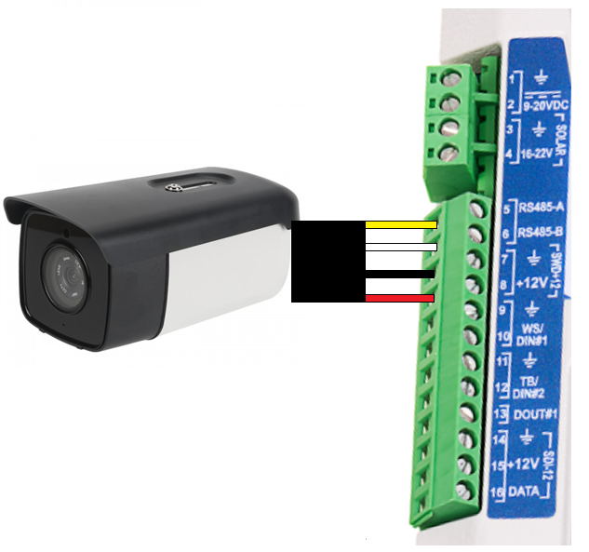

Camera485 has a 4-wire cable that is connected to the XLink-500’s RS485 and SW’D +12V power. See the picture above or the table below for connectivity.

|  |  |
| --- | --- |
| **XLink-500** | **Camera485** |
| RS485-A | Yellow Wire |
| RS485-B | White Wire |
| GND | Black Wire |
| SW’D +12V | Red Wire |

### **Configuring the Camera Script**

### **Overview**

The script is called Camera485.py and before loading it in to your XLink500 using LinkComm, you may wish to review or change the default settings in the program. To do so open the file in a text or program editor such as Notepad or PyCharm. The settings you may wish to change are defined as variables near the beginning of the program. Make any changes you wish and save the file.

The camera script is currently proprietary and should either be supplied with the camera or delivered separately via email.

Here is a high-level block diagram for the workflow of the program:

### **Settings**

This is a list of the settings that can be made by modifying the script (you may not need to change any of these settings, but consider the **bolded** items):

|  |  |  |
| --- | --- | --- |
| Variable | Default | Description |
| imageFolder | "/sd/Sutron/Camera485/ {YYYY}{MM}{DD}" | where to store each snapshot (folder may include elements of the current date and time)  {YYYY} is replaced by the 4-digit year {YY} is replaced by the 2-digit year {MM} is replaced by the 2-digit month {DD} is replaced by the 2-digit date {hh}{mm}{ss} are also supported  it is recommended to use date-based folders to avoid slow-downs and hitting the limit for the number of files that may be stored in a folder |
| **imageFileName** | "Camera485_{YY}{MM}{DD} {hh}{mm}{ss}.jpg" | what to name each snapshot (name may include elements of the current date and time)  {hh} is replaced by the 2-digit hour {mm} is replaced by the 2-digit minutes {ss} is replaced by the 2-digit seconds {YYYY}{YY}{MM}{DD} are also supported  use date and times to make sure each snapshot has a unique name |
| **txFolder** | "/sd/TX1" | where to store images for transmission, so for instance, if you prefer to configure your cell FTP with TX2, change this value to “/sd/TX2”  if you do not wish to transmit images, you may set this to None |
| leavePowerOn | False | option to leave the camera on (except in case of an error) to permit capturing pictures more often |
| **portPower** | "SW1" | how the camera is powered: None, "SW1", "SW2", "PROT12", "SDI1" or "SDI2"  we recommend you use “SW1” (or “SW2” on the Satlink3) to allow the software to reboot the camera when errors occur, to save power by not powering the camera when not needed, and to supply sufficient power to the camera. |
| ledMode | None | how to use the IR LED's of the camera: "ON" for on all time time, or None for auto switching  the camera does not support the option of not using the IR LED’s when it’s dark. |
| **useTextOverlay** | True | provide a text overlay to the camera to add to each image to display station name and a time stamp  the default text overlay contains the station name and the current time in MM/DD/YYYY HH:MM:SS format  the contents are generated by the GetOverlayText() function and this code can be modified to suit your own purposes, for instance you might wish to insert the value of a measurement |
| **overlayX** | 10 | horizontal pixel position of the text overlay |
| **overlayY** | 10 | vertical pixel position of the text overlay (the default value of 10, places the text near the top of the picture)  the overlay text will use black letters over light areas, and white letters of dark areas  for the best readability, try to position the overlay in a relatively static section of the picture |
| **overlayFontSize** | 16 | font height for the text overlay in pixels |
| defaultAddress | 1 | address of camera on the RS-485 bus |
| **defaultResolution** | "1280x720" | resolution to take pictures (horizontal pixels by vertical pixels)  supported resolutions are:  "640x480", "1280x960", "800x600", "1024x768", "1600x1024", "1600x1200", "1280x720", "1920x1080", "1280x1024", "480x270", "640x360", "800x450", "960x540", "1024x576", "1366x768", "1440x810", "1600x900"  higher resolutions may fail to snap if the resulting image is bigger than the camera's buffer and you will need to apply compression |
| **defaultCompression** | 3 | compression ratio (1 - 5) larger value is more compressed, 1 is the highest quality |
| retrySettings | [] | this is managed automatically according to the script task you select  it is a list of resolutions and compressions value to attempt in case the defaultResolution creates too large of an image for the camera  for instance, this list would retry at 1920x1080 at compression 5, and if that fails try 1280x720 with compression 1:  [(“1920x1080”,5), (“1280x720”,1)] |
| defaultTries | 2 | how many times to try an operation before failing (if one retry doesn't work, the camera probably needs to be power cycled) |
| defaultPowerCycles | 3 | how many times to cycle power and retry the transfer before failing |
| defaultPacketSize | 8192 | how much data to request from the camera at a time |
| defaultTimeout | 8.0 | how long to wait for a reply to a command |
| cameraWarmup | 3.5 | number of seconds to wait after power on before trying to communicate with the camera |
| free_space_limit_take | 64 | do not take a picture unless there are 64MB or more bytes free on the SDHC card |
| free_space_limit_archive | 256 | do not archive a picture unless there are 256MB or more bytes free on the SDHC card |
| maxPictureSize | 450000 | do not take pictures that will use more than 450,000 bytes  set this to an arbitrarily large number (1000000) to eliminate this limit  when using one of the automatic settings, retries at a higher compression level or lower resolution will be attempted until the image size falls below this limit |

### **Configuring the XLink2-500 to Take Pictures**

* insert a FAT32 MicroSD or MicroSDHC card in to the XLink2-500, files and folders will be created as needed. If you are using an SDHC card larger than 32GB, you will probably need to re-format the card (see Appendix: Formatting an SDHC card **with FAT32**). By default, pictures are archived to “Sutron\Camera485\<yyyy><mm><dd>” where “<yyyy><mm><dd>” are unique folder names based on the current date (ex: “20200513”). In addition, pictures are also stored in the “TX1” folder on the SDHC card for transmission. These files are automatically deleted after they’ve been transferred to a server.
* Run LinkComm (v3.7.9 or later) and connect to the station
* Configure the station name. This is imprinted as a text overlay on each photograph.
* On the Scripts tab, click Open Script File… and then browse to and select Camera485.py on your PC or device.
* Click S1
  + Check Active
  + Select the Script function “Take_1280x720_MediumDetail” (or one of the other resolutions).
  + Change the label if desired
  + Select the interval you wish to collect pictures (ex: 00:02:00)   
    (about the fastest that pictures can be collected at 1280x720 resolution is every 30 second, so one minute allows plenty of slack for variation, a 1920x1080 resolution picture may take over a minute to collect)
  + Select the time you wish to collect pictures (ex: 00:00:00)
* Click “Changed” and then “Send Setup to Station”
* (configure any measurements you may wish to make)
* Click “STOP Rec Off!”
* Verify the Camera is Taking Pictures:
  + Click “Script File Details”
  + Click the “Refresh” button below “Script Status”
  + Until the script runs the first time it will display “Script Task S1 never ran”
  + While it’s running the status will change to “Script Task S1 first run in progress”
  + When the first run completes, the status should look something like this:

|  |
| --- |
| Script Task S1 ran 1 times  last run result: success  last run started at 2020/05/13 22:35:01  last run completed at 2020/05/13 22:35:27  Script Function: Take­_1280x720_MediumDetail  Output:  Updated the camera's overlay  Camera imaged stored to /sd/Sutron/Camera485/20200513/Camera485_200513223501.jpg 150096 bytes  Total Pictures 1 Failures 0 Repower 0 Retries 0 No SD Card 0  Startup Time 4.0 secs  Transfer Time 18.5 secs  Total Time 24.1 secs  Throughput 8111.5 bytes per sec |

* + The individual fields in the status are explained below:

|  |  |
| --- | --- |
| Status Field | Description |
| Total Pictures x | x is the total number of pictures taken |
| Failures x | x is total number of failures to take a picture, and should be rarely seen as the software is designed to recover from a problem with retries and power cycling, however the SDHC card will eventually fill up if not swapped out periodically |
| Repower x | x is the number of times the camera needed to be re-powered in order to take a picture and should be low relative to the total number of pictures |
| Retries x | x is the number of times a command needed to be retried to get a reply from the camera |
| No SD Card x | x is the number of times the SDHC card was not inserted when attempting to take a picture (without somewhere to store the picture, the attempt is aborted) |
| Startup Time x secs | x is the number of seconds the camera needed to warmup before it would process a command |
| Transfer Time x secs | x is the number of seconds it took to transfer the image from the camera (higher resolutions and lower compression levels require more time) |
| Total Time x secs | x is the total time it took to acquire the picture and save it to the SDHC card, this number needs to be less than the interval pictures are taken |

### **Configuring the Cell Modem**

The Cell Modem is configured under “Other Setup” tab in LinkComm in the Cell section. You minimally need to do the following:

* **Cell**
  + Check “Enable”
  + Click “Modem Settings” and set the Cell APN (currently “NE01.vzwstatic” for Verizon)

In addition, if you enable incoming connections it’s recommended that you do so in combination with security features such as “Whitelist IPs” and “Cell user name” and “Cell password” under the “Modem settings”

When the Cell is configured, press the “Cell Diags…” button and confirm that station is able to get Online and everything looks ok. Note the phone number and IP address is displayed here.

### **Configuring the XLink2-500 to FTP Files Over Cell**

**Warning!** Make sure your Cell data plan is sufficient for transferring camera images. A 1280x720 (720P) picture with compression 3 can be 200KBytes and would consume 9 GBytes per month if 200KB was transmitted every minute.

You will need an FTP Server and the login credentials for the FTP server in order to proceed.

* Run LinkComm (v3.7.9 or later) and connect to the station
* Click the “Telemetry” tab in LinkComm
* Telemetry Setup
  + Check “Enable” (if it’s not already checked)
  + Change the “Radio type” to “Cell”
  + Change the Label if you wish
* Transmission Schedule
  + Select the “Scheduled time” and “Scheduled interval” you desire depending how frequently you would like to receive the latest images.
* Transmission Setup
  + Change the “Tx mode” to “FTP”
  + Check “Secure” if your FTP server supports FTPS
  + Change the “FTP Path” to “/TX1”
  + Change the “Main sever” to the URL or IP address of your FTP server
  + Change the “Server username” to your user name for your FTP Server
  + Change the “Server password” to your user name for your FTP Server
  + Verify the “FTP mode” is set to Passive unless you know your server requires Active
* Transmission Format
  + Change the “Data Source” to File
* Retry
  + Verify “Max tx time (min)” is set to 10
  + Change “Max files per TX” to 6
* Click “!Changed” and “Send Setup to Station”

Once the camera is taking pictures, the Cell is configured, and transmissions are setup, the final step is to make sure transmissions are going through. Press “Refresh” next to the “Telemetry Status” and if possible, wait until the next transmission and verify that the “Tx succeeded” count goes up. Alternatively, you can manually run the “TakePicture” script using the “Run Script Now…” button under the “Scripts” tab in the “S1” setup, and then go back to “Telemetry” “TX1” setup and click the “Transmit Now” button.

### **Logging and Transmitting Free Space on the SDHC card**

A script called “Free_Space_MB” permits the number of mega-bytes of free space on the SDHC card to be measure, logged, and/or transmitted. If an SDHC card is not inserted or could not be mounted the function returns a script error resulting in a bad value being logged (default is -99999.0).

To setup a measurement using LinkComm:

* Run LinkComm (v3.7.9 or later) and connect to the station
* Click the “Measurements” tab in LinkComm
* Select a measurement (ex: M1, M2, etc)
* Sensor
  + Check “Active”
  + Select a “Measurement type” of “Manual Entry”
  + Enter a “Label” of your choice (ex: “FREESPACE”)
  + Select the number of “Right digits” (ex: 3)
  + Enter the “Units” (ex: “MB”)
* Schedule
  + Select a Time (ex: 00:00:00)
  + Select an Interval (ex: 01:00:00)
* Processing
  + Check “Use script”
  + Choose “Free_Space_MB” for the “Script function”
  + Optionally use a slope or equation to scale the result, for instance if you know roughly how many MB per day the station will use, you could compute days of storage remaining by dividing by this factor.
* Logging
  + The data will be logged by default unless you uncheck “Log all”

To transmit the data, you will need to configure a “Telemetry” entry to send the data, and then you can select this in the measurement setup under the “Tx Content” section.

### **Final Considerations**

### **Removing or Replacing the SDHC Card**

The safest way to remove the SDHC card from the XLink-500 is to dismount it using the “file dismount sd” command from the command prompt. Using LinkComm, the command prompt may be accessed by pressing the Terminal button in the Diagnostics tab.

Here’s some other ways, that are not quite as effective due to the potential for background writes going on:

1. Stop recording before removing the card.
2. Set the “TakePicture” script “S1” to no longer be active before removing the card.
3. Remove power from the system before removing the card.

If you can just pull the card without taking any precautions, there’s a slight chance the file structure on the card could become damaged. In most cases, this can be repaired by putting the card in a PC and when prompted letting the PC repair the disk.

Interrupting a picture in progress can result in a partial image being stored on the card – this image may even be viewable, but part of the image will be missing.

### **Choosing a MicroSD or MicroSDHC card**

We have tested in house with commercial MicroSDHC cards as large as 256GB. Given the data logger will be exposed to temperature extremes, though, we recommend using cards designed for those extremes. For the highest possible reliability, we recommend industrial cards with fault tolerance such as the Swissbit S-455 line. These cards tend to be more expensive and may not be available in larger sizes. Some other brands which offer a line with fault tolerance and industrial temperature range include Panasonic, Delkin, and Transcend. Most of these cards cost over $100 for an 8GB card as they often use the more expensive SLC-based Nand chips. A more reasonably price option is the Kingston Industrial MicroSDHC card, which is designed to be reliable, rugged, and operate down to -40C; but lacks the failsafe features of the more expensive cards. We’ve also tested with standard commercial cards which are often rated down to -20C, but they are not specifically designed for permanent installation in outdoor equipment.

MicroSDHC cards are often marked with speed/compatibility ratings such as class 10, UHS-1, SDXC, etc. We have not seen any compatibility issues, as the newer standards seem to be sufficiently backwards compatible. The “file test” command may be used to perform a simple benchmark of the card performance.

### **Surge Protection**

The camera has surge protection but may be damaged by a significant surge or near lightning strike.

### **Appendix: Formatting an SDHC card with FAT32**

The SDHC card must be formatted as FAT32. This is typically not a problem for cards of 32GB or smaller as they generally are pre-formatted as FAT32, however larger cards are usually formatted with exFat which is not compatible with the XLink2-500. In addition, while it’s possible to format a disk larger than 32GB with FAT32 using a PC, it’s not easy to do without using 3rd party programs. Here’s how it can be done using LinkComm and the XLink2-500:

* + On the Diagnostics tab, click the Terminal button to open the terminal interface.
  + Type the command “file info sd”
  + If the response is “Drive is not mounted” then the XLink2-500 was not able to read the card and you will probably need to format the card before you’ll be able to use it. **Warning**! formatting the card will delete any and all data that was previously on the card.
  + Using the Communications history section, type the command “file format sd”, then press “Y” when prompted and then “Y” again. You should see “Formatting…”
  + After a while (a 128GB card took 30+ seconds) you should see “Format Complete” and the card should be ready to use.
  + Issue the command “file info sd” to verify the capacity.
  + Issue the command “file test” if you wish to verify that the XLink2-500 can read and write the card.